# M6.16 - Refinements to XML-based workflow for peer-review based on user feedback

**Leading partners:** Pensoft, NHM

**Compiled by:**

Lyubomir Penev, Teodor Georgiev, Pavel Stoev, Jordan Biserkov, Margarita Grudova

November 2012

# Three online user surveys were carried out in 2012 by Pensoft in the frame of the project ViBRANT aiming at receiving feedback from:

# ZooKeys’ authors and reviewers on the editorial workflow and the existing journal services;

# Bioinformaticians on the interface and functionalities of the Pensoft Writing Tool (PWT) (fig. 1);

# Scientific (mainly taxonomic) community of their interest in participating in the Biodiversity Data Journal project.

# The results of the tree surveys have been analysed in Vibrant Deliverable 6.2, and won’t be an object of further discussion in the present document. However, based on the analysis and respondents suggestions, the authoring and editorial processes of the Biodiversity Data Journal have been significantly refined. In addition to several purely technical suggestions for improvement of e.g., the PWT Taxon treatments and Comments interface, some brand new features, such as Community and Public review processes (Fig. 2) were implemented into the system. The scope of BDJ and the general workflow, from generation of manuscript in PWT to submission and publication to the Biodiversity Data Journal (Fig. 3), and dissemination of the published in BDJ content have been elaborated as described below. Guidelines for authors, reviewers and editors have been prepared, explaining in detail the steps of manuscript creation and its processing and the criteria for evaluation of the manuscripts.

**Key features of the Biodiversity Data Journal**

Biodiversity Data Journal (BDJ) is a community peer-reviewed, open-access, comprehensive online platform, designed to accelerate publishing, dissemination and sharing of biodiversity-related data of any kind. All structural elements of the articles – text, morphological descriptions, occurrences, data tables, etc. – will be treated and stored as DATA, in accordance with [Pensoft’s Data Publishing Policies and Guidelines](http://www.pensoft.net/J_FILES/Pensoft_Data_Publishing_Policies_and_Guidelines.pdf). The journal will publish papers in biodiversity science containing taxonomic, floristic/faunistic, morphological, genomic, phylogenetic, ecological or environmental data on any taxon of any geological age from any part of the world with no lower or upper limit to manuscript size. For example:

* single taxon treatments and nomenclatural acts (e.g., new taxa, new taxon names, new synonyms, changes in taxonomic status, re-descriptions, etc.);
* data papers describing biodiversity-related databases, including ecological and environmental data;
* any kind of sampling report, local observations or occasional inventories;
* local or regional checklists and inventories;
* habitat-based checklists and inventories;
* ecological and biological observations of species and communities;
* any kind of identification keys, from conventional dichotomous to multi-access interactive online keys;
* descriptions of biodiversity-related software tools.

Text and data submitted to **Biodiversity Data Journal** will be formally peer-reviewed and evaluated for technical soundness and the correct presentation of appropriate and sufficient metadata. The scientific quality and importance of the paper and data will be judged by the scientific community, through a novel *community-based pre-publication and post-publication peer-review.* Authors may also opt for an entirely open and public peer-review process. Reviewers may opt to be anonymous or to disclose their names. The deadlines for the peer-review and editorial processes are strict and limited to a maximum of two months after submission. The peer review process and deadlines described below are articulated on the assumption that the contribution is a short, concise and technically written manuscript that is not expected to require much time from the reviewer.

**Criteria for publication**

**Originality:** Papers and associated data should be sufficiently novel and contribute to a better understanding of the topic under scrutiny.

Example 1: A local checklist is considered novel if it includes new data from a locality; a local checklist is not considered novel if it is mostly confirmatory and repetitive and lists common species from a locality in a well-studied region.

Example 2: Occurrence data are considered novel if they significantly extend the range (geographical, temporal or habitat type) of a axon, present intriguing biogeographical discoveries, concern taxa of high natural or social importance (e.g., invasive species); or feature taxa that are data-poor; occurrence data will be not be considered novel, if they only list new localities of a well-known and common (data rich) taxon within a well-studied region.

Example 3: Ecological and biological observation on any species from any region of the world are considered novel always when they do not repeat already published information.

**Data are published**: All data underpinning an article, including data tables on which graphs are produced, must be published alongside the paper, e.g. as supplementary files, or links to external repositories where data are deposited, and contain sufficient metadata to facilitate data discovery.

**Structure:** Manuscripts should be concisely written, in a good academic style, and follow a logical sequence. Results should be clearly and concisely described and supported by the data published with the article, or data published elsewhere but linked to the article.

**Previous research:** Previously published information should be considered and cited in compliance with the good academic practice. References should be complete and accurate, where possible including DOIs or links to the article.

**Stepwise description of the peer review and editorial process**

1. Upon submission, the manuscript is automatically assigned to the Subject Editor responsible for the topic. The Subject Editoris alerted by email.

2. The Subject Editor reads the manuscript and decides if it complies with the journal's scope and should be processed for peer-review.

3. The Subject Editor sends review requests to two or three “nominated” reviewers and several other “panel” reviewers.

Note-1: “Nominated” and “panel” reviewers. “Nominated”” reviewers are expected to provide a thorough review; they can Track/Change corrections and comments in the manuscript online. ”Panel” reviewers are expected to evaluate the manuscript through a concise online form; they can only comment on the manuscript.

Note-2: How editors invite reviewers. The journal's database will provide a list of potential reviewers and if necessary the editor can add additional names to the list. Review requests will be emailed by a ‘single-click’ option.

Note-3: “Community” and “public” peer review. “Community” peer review means that during the peer-review process the manuscript is visible only to editor, the reviewers and the authors; this is the default option. The authors may opt, however, to make their manuscript available for comment by registered journal users (“public” peer review). Reviewers may opt to stay anonymous or disclose their names in either case.

Note-4: “Open” and “blind” peer review. “Open” peer review means that comments, corrections and reviews are visible to the nominated and panel reviewers (independent of whether they decide to stay anonymous or disclose their names), editors and the authors. “Blind” peer review means that nominated and panel reviewers do not see each other’s reviews. The default option is “blind” peer review process but authors may opt for “open” peer review. In this and all other cases, the reviewers will have the option to stay anonymous.

4. The Subject Editor receives a notification email if the nominated reviewer agrees or declines to review the manuscript. In the latter case the editor will appoint alternative nominated reviewers.

5. Reviews are required to be submitted within three weeks; the whole review process lasts five weeks from the date of the first invitation to reviewers. The Subject Editor will then decide to accept, reject, or request revision of the manuscripts. If the reviewers fail to submit their comments on time, the Subject Editor will consult the managing Editor.

Note-5: Provision of reviews. Reviewers will be prompted by automated email notification sent seven days before the deadline. In case of delay, the review request will be cancelled automatically; nonetheless, after cancelation, reviewers will be invited once more to share their opinion with the editor.

6. The authors must provide a revised version of their manuscript within one week, but can ask for an extension, if there is an obvious need.

7. After submission of the revised version, the Subject Editor compares it against the reviews through an easy-to-use online tool and decides to accept or reject the manuscript. The authors may be asked to make additional revisions, OR in case of substantial changes, the reviewing procedure will be started again. The editorial decision and correspondence with the authors (if needed) is expected to take maximum of two weeks.

8. The manuscript will be formatted, proof-read, copy-edited and published within two weeks after acceptance.

Peer reviewers and editors of the Biodiversity Data Journal are expected to evaluate the completeness and quality of the manuscript text, related dataset(s) and their description (metadata), as well as the publication value of data. This may include the appropriateness and validity of the methods used, compliance with applicable standards during collection, management and curation of data, and compliance with appropriate metadata standards in the description of the data resources.

The following aspects of evaluation will be considered:

**Quality of the manuscript**

* Is the paper sufficiently novel and contributes to a better understanding of the topic, or is the work rather confirmatory and repetitive?
* Do the title, abstract and keywords accurately reflect the contents and data?
* Is the manuscript internally consistent, suitably organised and written in grammatically correct English?
* Are the relevant non-textual data and media (data sets, audio and video files) also available as supplementary files to the manuscript or as links to external repositories?
* Have abbreviations and symbols been properly defined?
* Does the manuscript put the data resource being described properly into the context of prior research, citing pertinent articles and datasets?
* Are conflicts of interest, relevant permissions and other ethical issues addressed in an appropriate manner?

**Quality of the data**

* Are the data completely and consistently recorded within the dataset(s)?
* Does the data resource cover scientifically important and sufficiently large region(s), time period(s) and/or group(s) of taxa to be worthy of publication?
* Are the data consistent internally and described using applicable standards (e.g. in terms of file formats, file names, file size, units and metadata)?
* Are the methods used to process and analyses the raw data, thereby creating processed data or analytical results, sufficiently well documented that they could be repeated by third parties?
* Are the data plausible, given the protocols? Authors are encouraged to report any tests undertaken to address this point.
* Is the repository to which the data are submitted appropriate for the nature of the data?
* Consistency between manuscript and data
* Does the manuscript provide an accurate description of the data?
* Does the manuscript properly describe how to access the data?
* Are the methods used to generate the data (including calibration, code and suitable controls) described in sufficient detail?
* Is the dataset sufficiently novel to merit publication?
* Have possible sources of error been appropriately addressed in the protocols and/ or the paper?
* Is anything missing in the manuscript or the data resource itself that would prevent replication of the measurements, or reproduction of the figures or other representations of the data?
* Are all claims made in the manuscript substantiated by the underlying data?

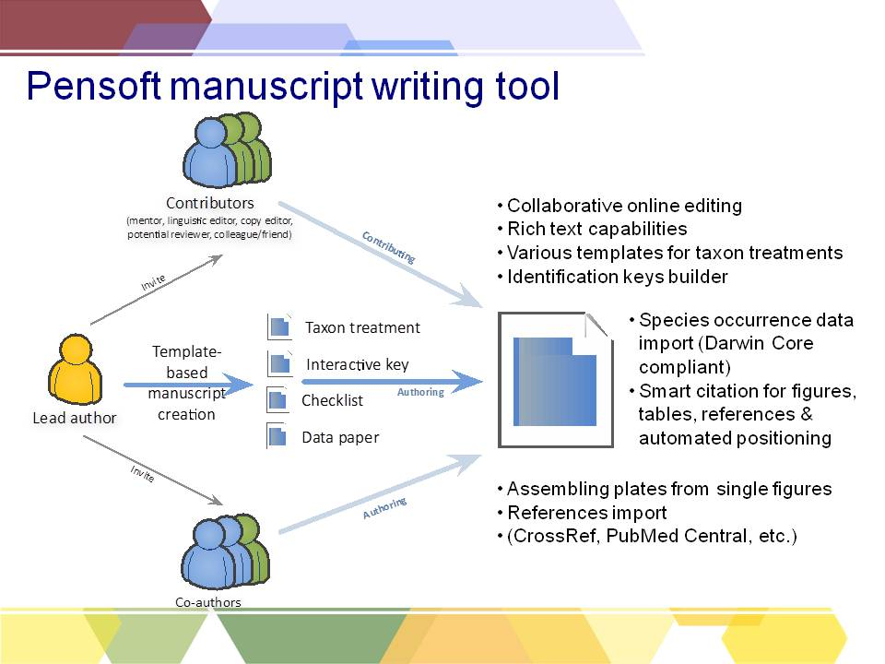

Fig. 1. A chart showing the work flow and main features of the Pensoft Writing Tool (PWT).

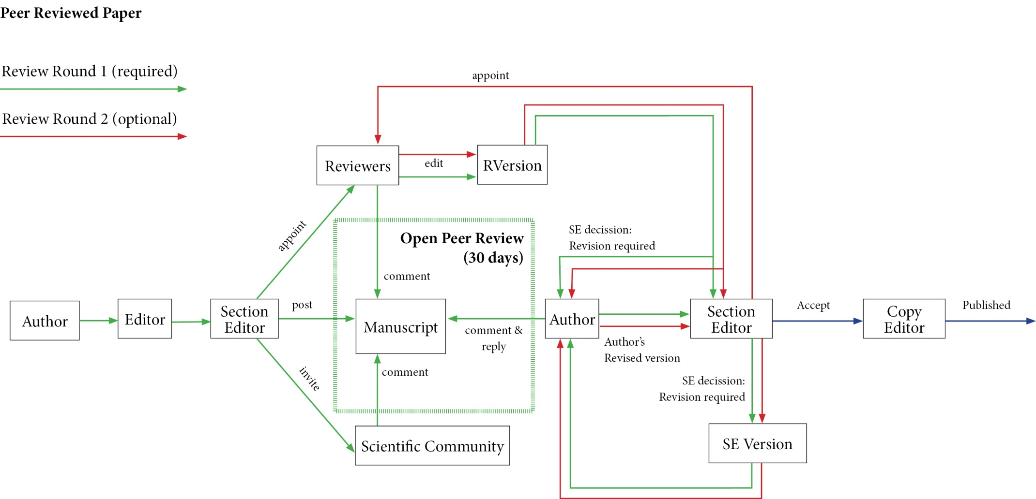

Fig. 2. A chart showing the basic model and work flow of an open peer-review process

F:\ViBrant_deliverable\Pages from Drawing1.tif

Fig. 3. A chart showing the Biodiversity Data Journal XML work flow, from creation of manuscript in PWT or export from Scratchpads, to PJS and integration of the published content into major data aggregators.